Weicong Feng

Brief analysis basing on the 311 complaints records in New York from 2010 to 2018

311 Performance Analysis

ISI CSI

Contents

Abstract 2

Methodology 2

Analysis 2

Distribution of Complaints 2

Average Duration 5

Long Duration Complaints 7

Conclusion 8

# Abstract

311 is New York City's one-stop shop for all government information and non-emergency services. People can complain by phone call and online. There are thousands complaint calls every day. It has great contribution for improving the lives of New Yorkers. However, there are some issues, for example, response speed and efficiency. With the increase of people’s dependence of 311, it is more and more necessary to analyze its existing problem and optimize allocation of resources.

# Methodology

The detail records about complaints from 2010 to present is freely available from the NYC open data website. That data set includes more than 20.6 million records and 41 columns, involves 30 agencies.

The data set includes rich information, including requirements created date, closed date, agency, complaint type, borough, address, geographic coordinate, and so on. In order to getting the overall picture, we also need the number of complaints grouped by agencies and borough, and average duration of processing grouped by agencies. In general, there are two approaches to obtain these data: calculating it by language like Python or R, using application like Excel or SAS. In this report, we use Power BI to produce new data and visualize.

# Analysis

There are 20.6 million complaint records in this data set, which includes the complaints coming from 311 from 2010 to the end of 2018. In order to understand whether the complaint processing is reasonable or has problems, I added a duration field based on the original data set, which is equal to the closed date-created date. All complaints sum up to total 72 million days. On average, each complaint took 3.5 days to process.

## Distribution of Complaints

What percentage of all complaints are about different agencies, and how many are filed separately?

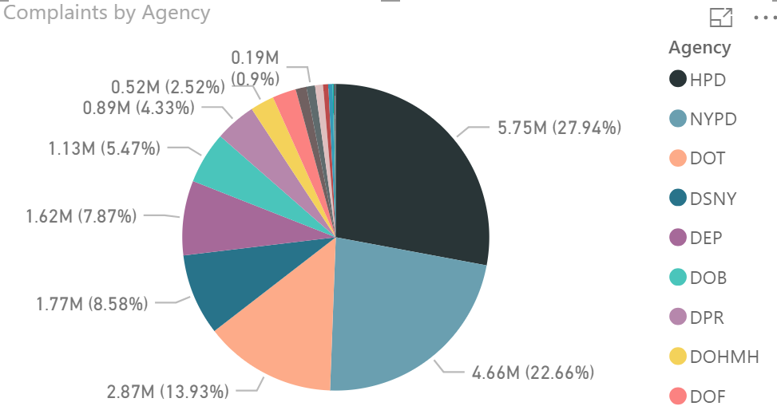

As shown above, the complaints of the largest two agencies account for more than half of all complaints, HPD (Housing Preservation & Development) and NYPD (New York Police Department). From the perspective of the type of complaint, there is no so concentration as agency. The higher proportions include: Noise, Heat/hot water, Street condition, Heating, Street light condition, blocked driveway, and so on. From these analysis, increasing resource investment of HPD and NYPD, and improving their efficiency could effectively improve 311 service.

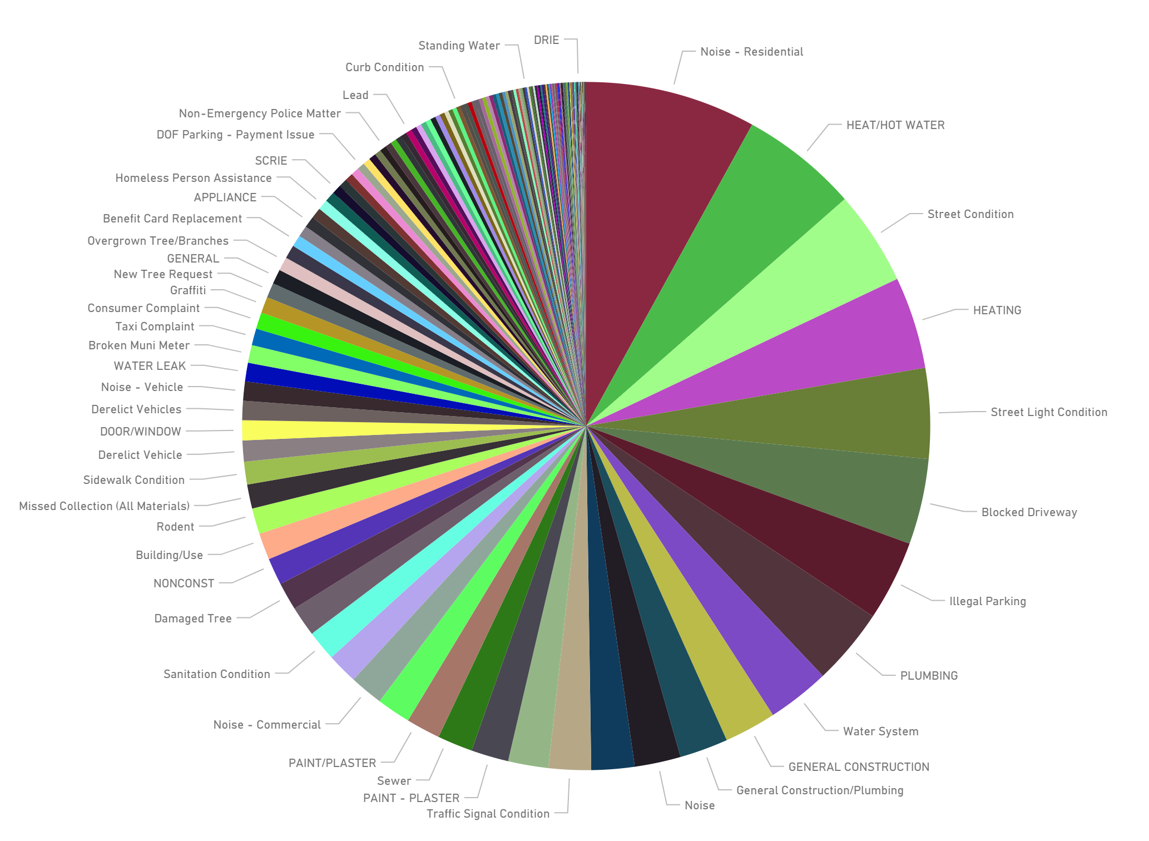

Let us see if there is anything special about the distribution of complaints from the perspective of the borough.

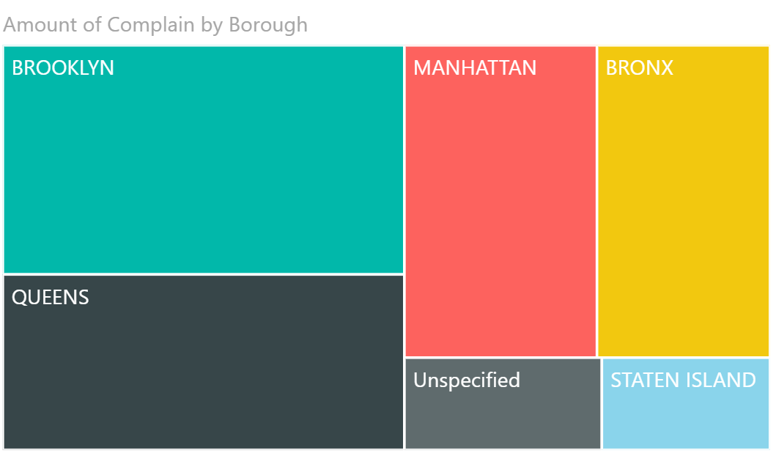

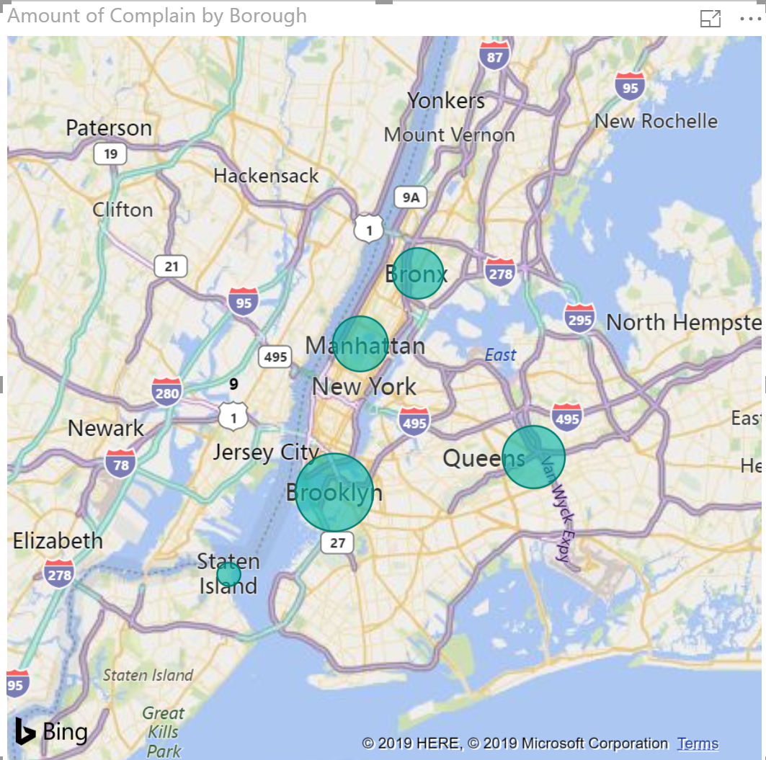

It shows that the complaints from Brooklyn and Queens account for more than half of total complaints, the proportion of Manhattan and Bronx are the next, and Staten Island is the least.

## Average Duration

Duration is the fact we concern most. The original data set does not include a duration information. So, a “duration” field was created by being calculated by the difference between “closed date” and “created date”. However, a lot of data are wrong, that is the “closed date” is earlier than the “created date”. What can we do is to eliminate this kind of data.

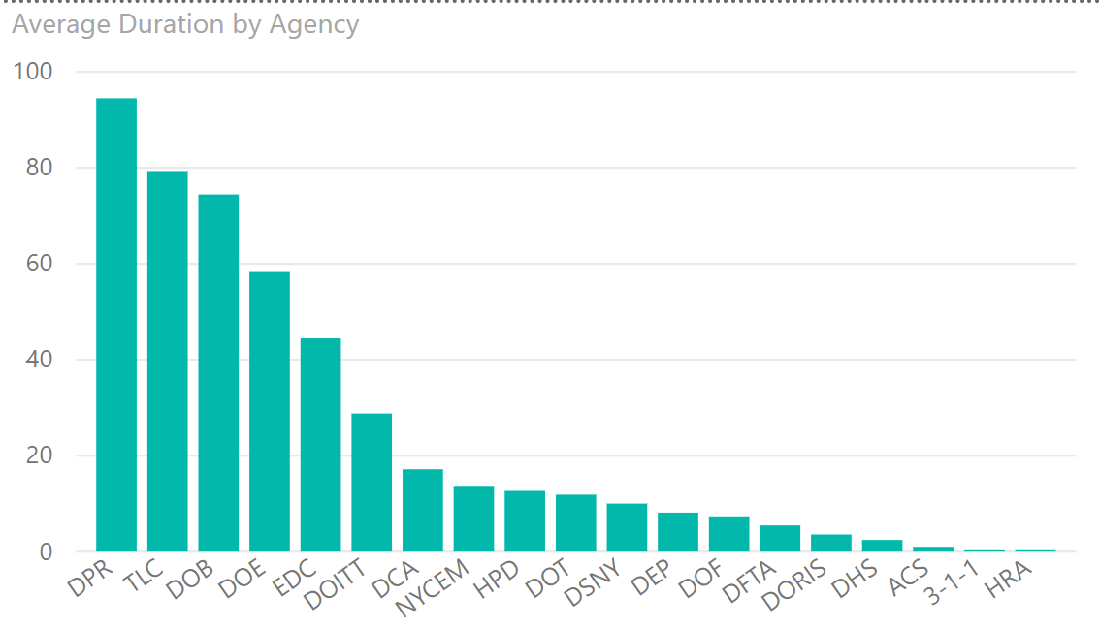

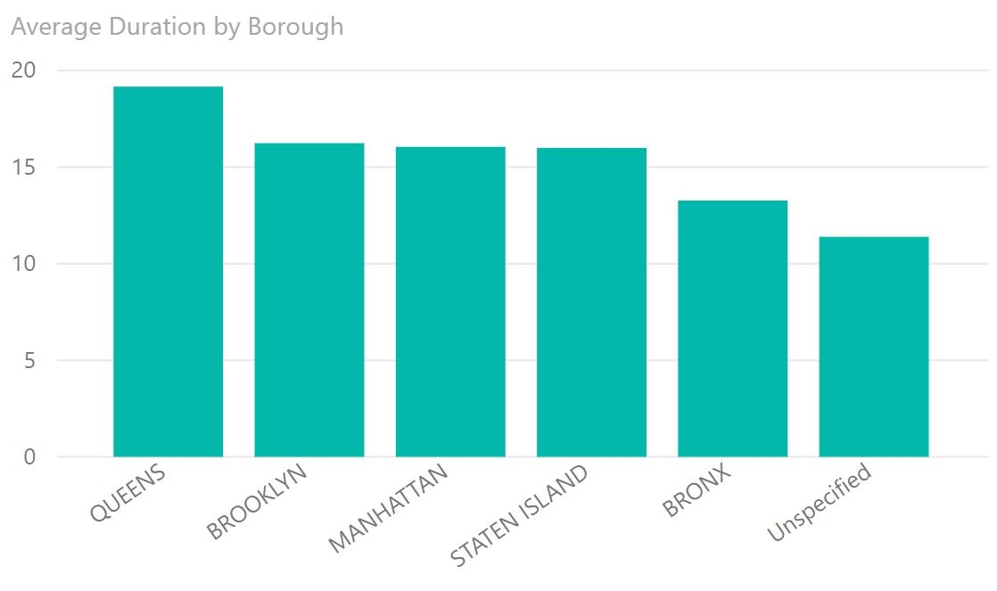

From above figures, following conclusion could be drawn:

1. The departments with the longest average complaints processing time, which need to be noted and further analyzed are:

* DPR
* TLC
* DOB
* DOE
* EDC
* DOITT

1. The borough with the longest average complaints processing time is Queens, the borough with the least of that is Bronx. The processing efficiency of Queens need to be paid attention to if it is not affected by other specific factors.
2. The data need to be improved further, for example, the accuracy of “closed date” and “created date”, and unspecified borough.

## Long Duration Complaints

To further investigate the reasons for the “poor performance departments”, following analysis were done:

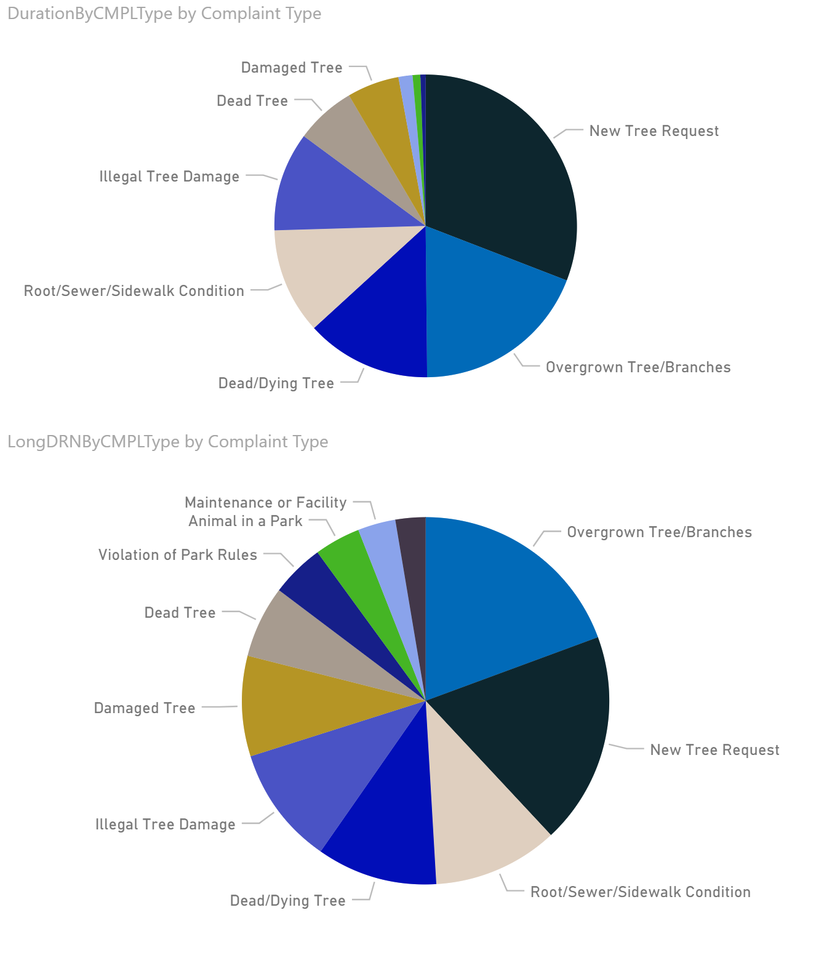

Above two figures are the pie charts of proportion of different complaint types of average duration in all DPR complaints which is the highest average duration agency. The difference of these two figures is that the top one includes all complaints, and the lower one filters the complaints of which average duration are lower than 20 days. It could be a good idea to check if it is possible to optimize the process of several types of complaints that account for a larger proportion, such as overgrown tree/branches, new tree request, sidewalk condition, and so on.

If we look at the average processing time, or duration, of all types of complaints in all agencies, that of the “Found Property” is much longer than others.

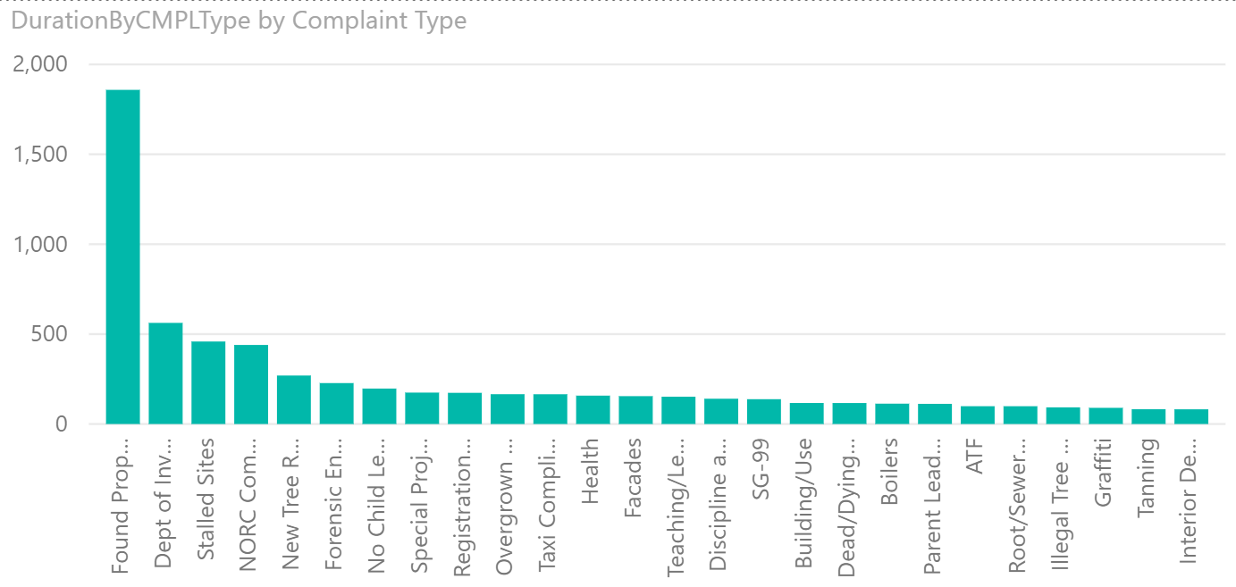

Although we can understand that finding loss property is a time consuming job, the average duration of 1858 days is crazy. It seems a more sensible choice to find a standard that can discriminate what kind of cases has bare chance, and close the cases after a period of time instead of hanging on for years.

# Conclusion

After the above simple analysis, the following conclusions can be drawn:

1. 40 agencies handle more than 6000 complaints per day in 311;
2. The distribution of the amount of complaints is uneven, mainly concentrate in Brooklyn and Queens, or HPD and NYPD;
3. The agencies with longer average duration are: DPR, TLC, DOB, DOE, EDC, DOITT;
4. The longest average duration of complaint types is “Found Property”, which has incredible 1858 days. Corresponding countermeasures should be taken;
5. The complaint type with the longest average duration in DPR, the agency with the longest average duration, are new tree request, overgrown tree, sidewalk condition, that should be concerned about;
6. The data collection should be more careful, and improve the accuracy.